

**A PROJECT PRESENTATION**

**ON**

**QuickBuy (Online Shopping Application)**

**SUBMITTED BY**

**Group No - 13**

KURBANALI A MASU - 18082221021

**B.Sc.(CA&IT) – VI**

**U16A5PRII – Industrial Project - II**

**PROJECT INTERNAL GUIDE**

Mr. Jaimit R Patel

**SUBMITTED TO**

**Department of Computer Science,**

**Ganpat Vidyanagar – 384012**

**ACKNOWLADGEMENT**

I have taken efforts in this project. However, it would not have been possible without the kind support and help of many individuals and organizations. I would like to extend my sincere thanks to all of them.

I am highly indebted to (DCS department of computer science) for their guidance and constant supervision as well as for providing necessary information regarding the project & also for their support in completing the project.

I would like to express my gratitude towards my parents & members of (department of computer science(DCS))for their kind co-operation and encouragement which helped me in completion of this project.

I would like to express my special gratitude and thanks to industry persons for giving me such attention and time.

My thanks and appreciations also go to my colleague in developing the project and people who have willingly helped me out with their abilities.

**PREFACE**

E-commerce as anything that involves an online transaction. E-commerce provides multiple benefits to the consumers in form of availability of goods at lower cost, wider choice and saves time. The general category of e-commerce can be broken down into two parts: E-merchandise: E-finance. E commerce involves conducting business using modern communication instruments: telephone, fax, e-payment, money transfer systems, e-data interchange and the Internet. Online businesses like financial services, travel, entertainment, and groceries are all likely to grow. Forces influencing the distribution of global e-commerce and its forms include economic factors, political factors, cultural factors and supranational institutions.

**INDEX**

|  |  |  |
| --- | --- | --- |
| **sr.no** | **Title** | **Page.no** |
| **1** | **Project Profile** | **01** |
| **2** | **Existing System** | **02** |
| **3** | **Need for new system** | **02** |
| **4** | **Hardware requirement** | **03** |
| **5** | **Software requirement** | **03** |
| **6** | **Users of application** | **04** |
| **7** | **User module specification** | **04** |
| **8** | **Admin module specification** | **04** |
| **9** | **System flow chart** | **05** |
| **10** | **E-R diagram** | **07** |
| **11** | **Data flow diagram** | **08** |
| **12** | **Data dictionary** | **10** |
| **13** | **User side design** | **15** |
| **14** | **Admin side design** | **30** |
| **15** | **Test case** | **40** |
| **16** | **Limitation of system** | **47** |
| **17** | **Future enhancement** | **48** |
| **18** | **Bibliography** | **49** |

1. **PROJECT PROFILE**

|  |  |
| --- | --- |
| **Project Name** | **QuickBuy** |
| **Objective** | E-Commerce drives profitable growth by expanding customer reach, reducing cost-to-serve, and creating differentiated customer experiences |
| **Front End Tool** | Swift 5.3 |
| **Back End Tool** | Firebase |
| **Other Tools** | XCode (12.1) , Algolia |
| **Platform of application** | Mobile (IOS) |
| **Internal Project Guide** | Mr. Jaimit R Patel |
| **Time Duration** | 120 Days |
| **Submitted to** | Department of computer science, GANPAT UNIVERSITY |

**2. EXISTING SYSTEM**

* In the existing system, customer have to go at store and then buy the products.
* In the traditional type of system, customer have limited options of the products while in the E-Commerce application customer have huge amount of options.
* If we have to buy various types of products in traditional type of system, we have to visit different stores.

**3. NEED FOR NEW SYSTEM**

* Customers can spend less time to shop for what they want. They can easily browse through many items at a time and buy what they like.
* In E-commerce application, customer can buy cheaper products compare to traditional store.
* E-Commerce application allows you to provide more information about your products to customer.

**4. HARDWARE REQUIREMENT**

|  |  |
| --- | --- |
| **SERVER SIDE** | |
| System | Any Web-browser supporting system |
| Disk Space | 1GB Free space Recommended |

|  |  |
| --- | --- |
| **CLIENT SIDE** | |
| System | Any IOS Mobile device |
| RAM | 2GB or more |
| Disk Space | 1GB or more |

**5. SOFTWARE REQUIREMENT**

|  |  |
| --- | --- |
| **SERVER SIDE** | |
| Web Browser | Any web browser for Firebase SDK |

|  |  |
| --- | --- |
| **CLIENT SIDE** | |
| IOS Version | IOS version 13 or later |

**6. USERS OF THE APPLICATION**

* CUSTOMER
* ADMIN

**7. CUSTOMER MODULE SPECIFICATIONS**

* REGISTRATION
* LOGIN
* SEARCH ITEM
* MANAGE CART
* MANAGE ORDERS
* MANAGE PROFILE

**8. ADMIN MODULE SPECIFICATIONS**

* LOGIN
* ADD ITEMS
* UPDATE ITEM
* DISABLE ITEM
* MANAGE CUSTOMER’S ORDERS

**9. SYSTEM FLOW-CHART**

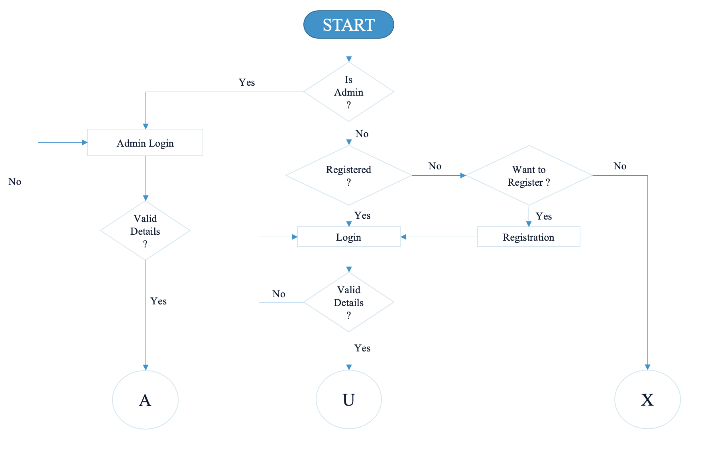

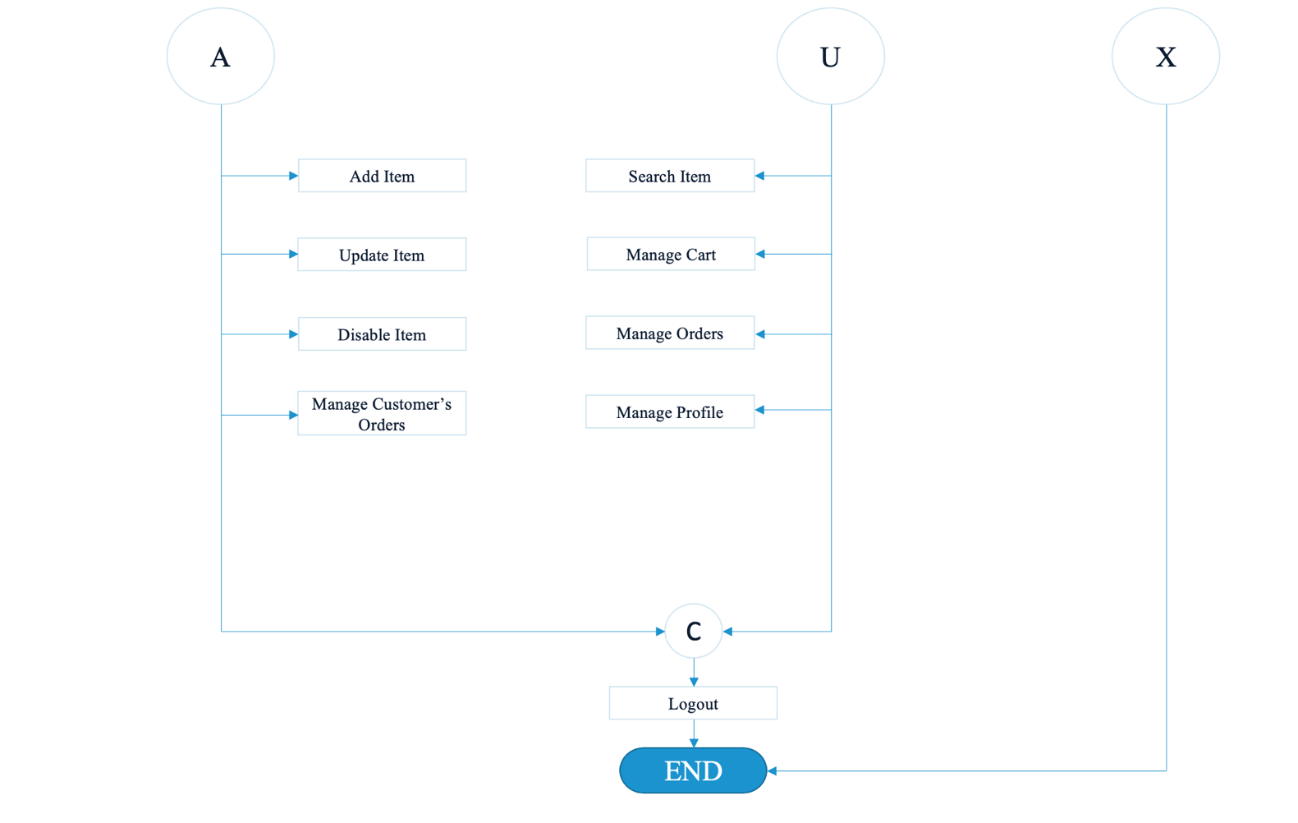

**10. E-R DIAGRAM**

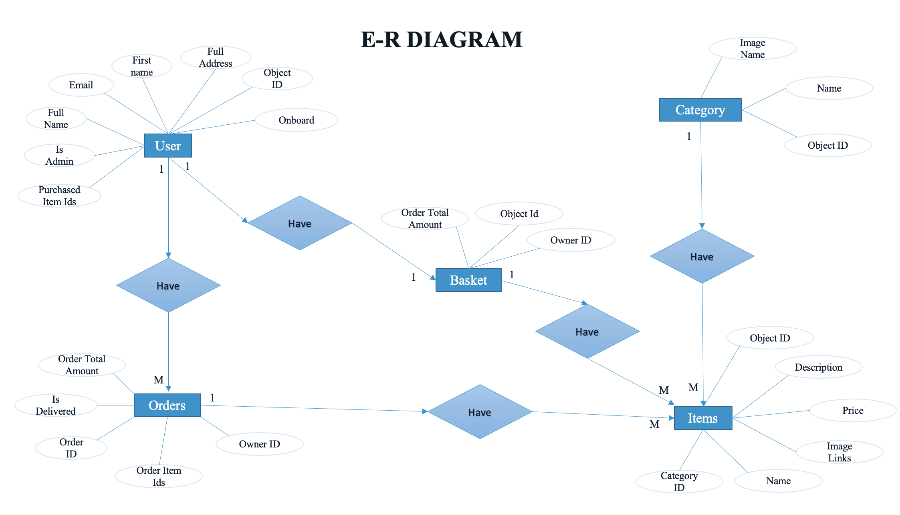

**11. DART FLOW DIAGRAM**

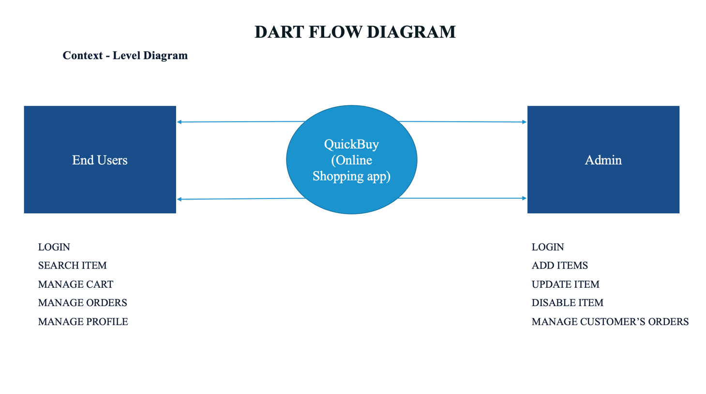

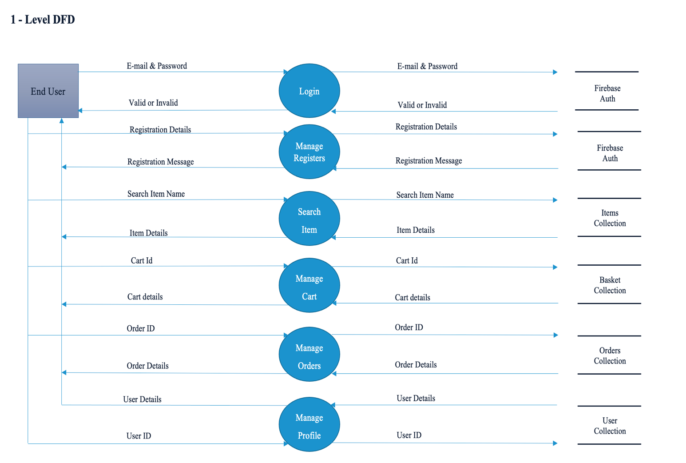

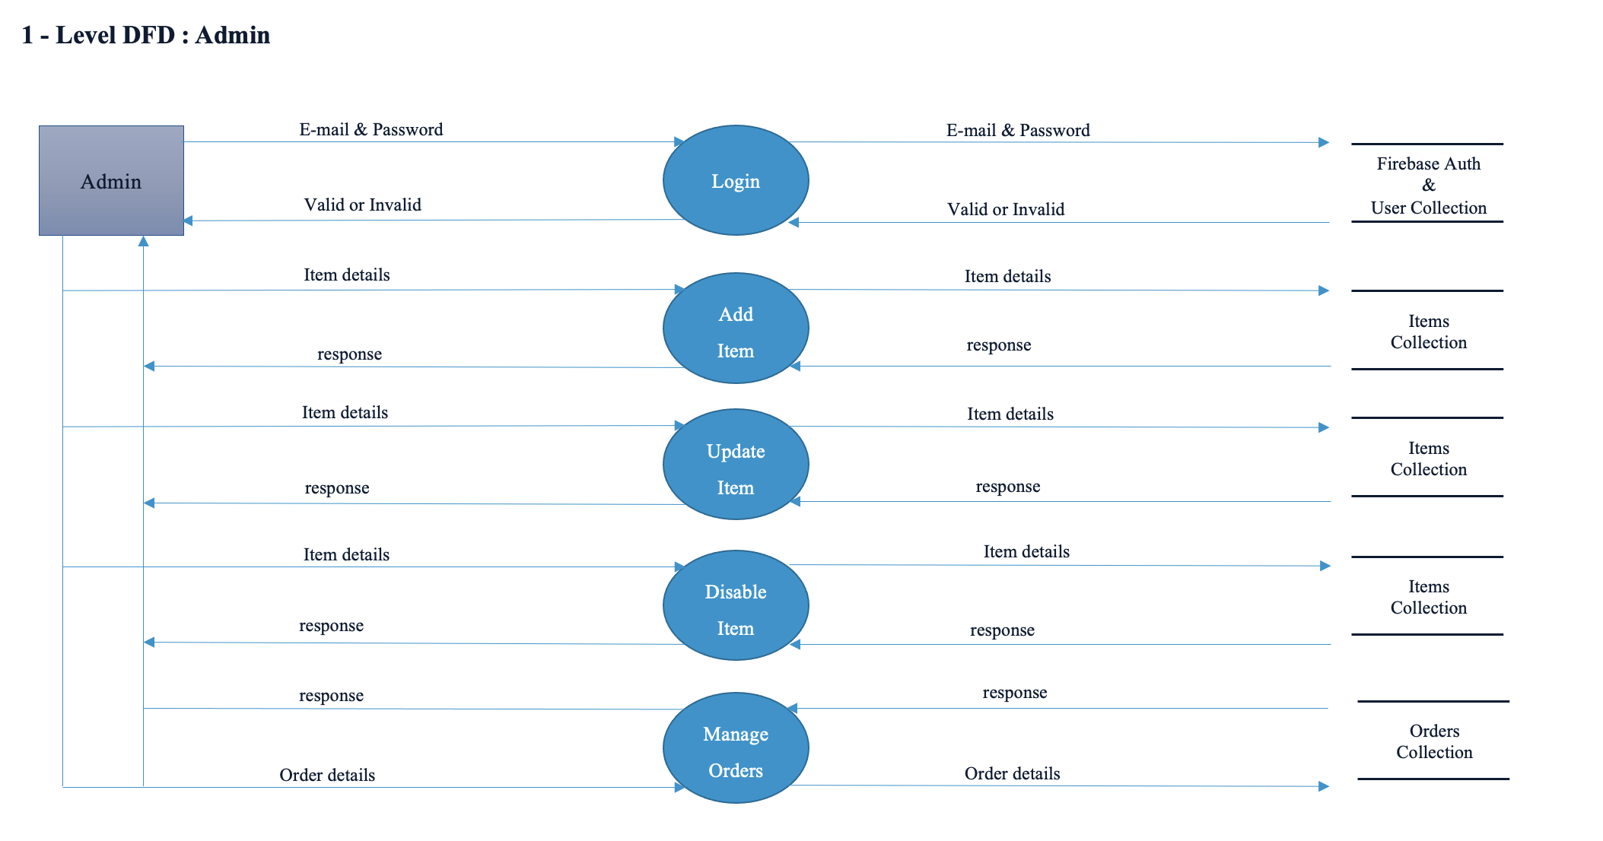

**12. DATA DICTIONARY**

1. Users Collection

* User collection stores the data of the users of application

|  |  |  |
| --- | --- | --- |
| **Collection** | **Documents** | **Fields** |
| Users | Document Name (String) | Email : String  First Name : String  Last Name : String  Full Address : String  Full Name : String  Is Admin : Bool  Object Id : String  Category Id: String  On Board : Bool  Purchase Item Ids : Array (String) |

* Object Id 🡪 Object Id is a document name in each user’s document field.
* Category Id🡪 Category Id refers the category of item from category collection.
* On Board🡪 On board shows the have finished registration or not.

1. Category Collection

* Category collection stores the items master type from where we can categories our items

|  |  |  |
| --- | --- | --- |
| **Collection** | **Documents** | **Fields** |
| Category | Document Name (String) | Name : String  Image Name : String  Object Id : String |

* Object Id 🡪 Object Id is a document name in each category’s document field.

1. Items Collection

* Items collection stores the data of the items

|  |  |  |
| --- | --- | --- |
| **Collection** | **Documents** | **Fields** |
| Items | Document Name (String) | Name : String  Category Id : String  Description : String  Image Links : Array(String)  Object Id : String  Price : Double  IsActive : Bool |

* Object Id 🡪 Object Id is a document name in each Item’s document field.
* Is Active 🡪 Is active shows the current item is active or not

1. Basket Collection

* Basket collection stores the data of the basket per user

|  |  |  |
| --- | --- | --- |
| **Collection** | **Documents** | **Fields** |
| Basket | Document Name (String) | Item Ids : Array (String)  Object Id : String  Owner Id : String |

* Object Id 🡪 Object Id is a document name in each basket’s document field.
* Owner Id 🡪 Owner id represents the owner of the current

basket

1. Orders Collection

* Orders collection stores the data of the all user’s all orders.

|  |  |  |
| --- | --- | --- |
| **Collection** | **Documents** | **Fields** |
| Orders | Document Name (String) | Is Delivered : Bool  Order Id : String  Order Total Amount : Double  Order Item Ids : Array (String)  Owner Id : String |

* Order Id 🡪 Order Id is a document name in each Order’s document field
* Is Delivered 🡪 Is delivered shows the status of order

delivery

**13. USER SIDE DESIGN**

* Splash Screen

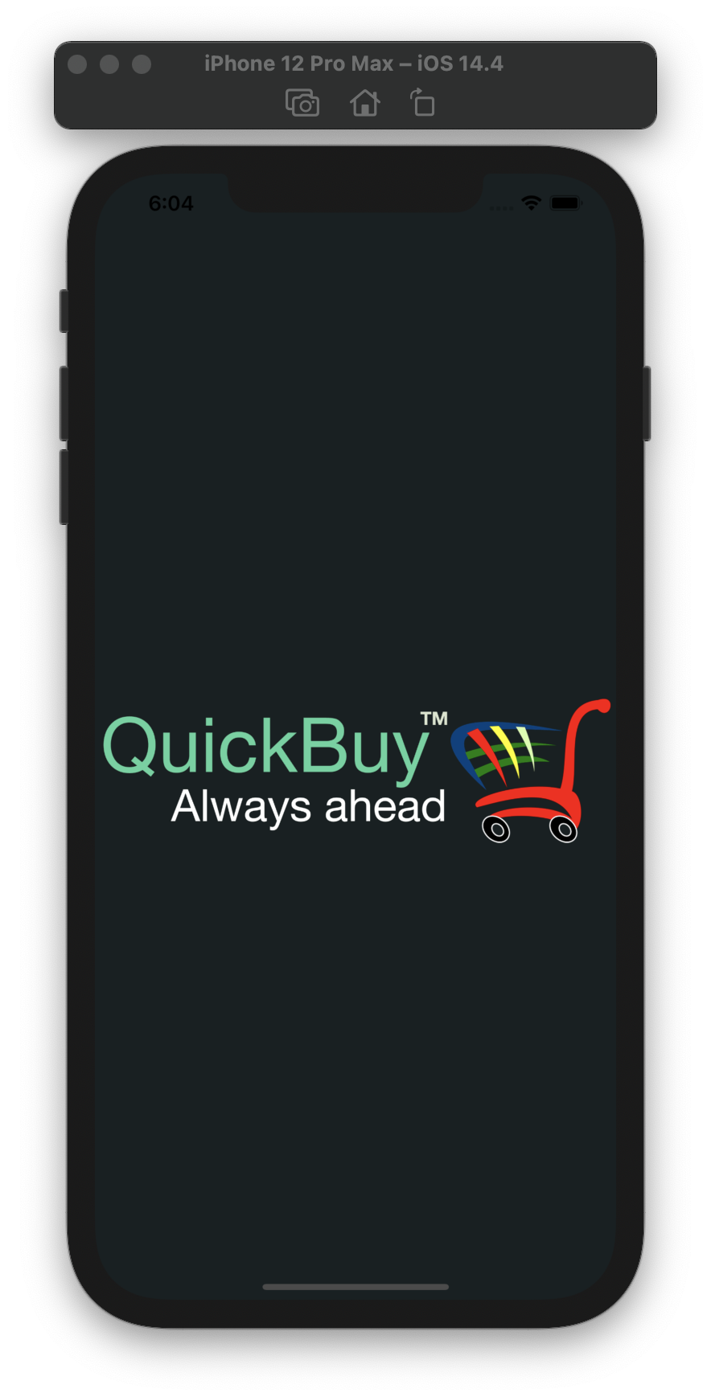

* Login Screen

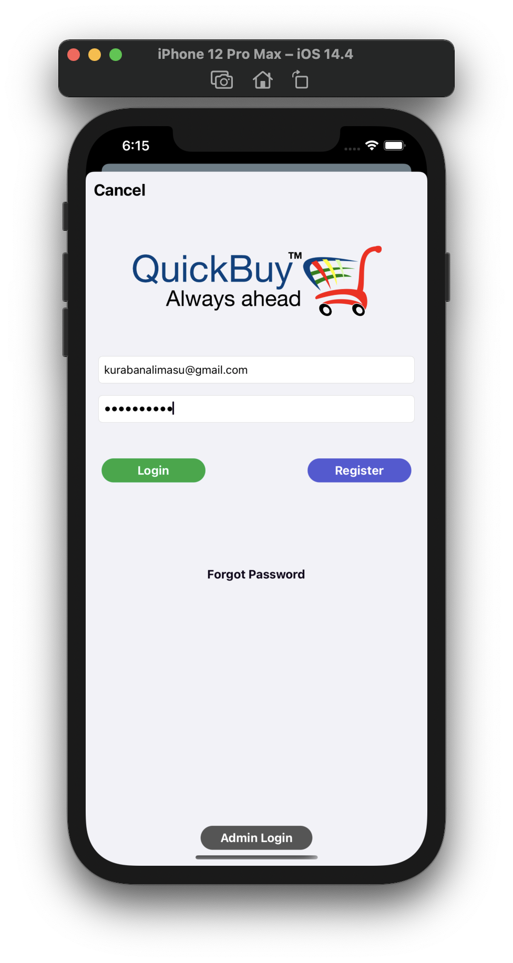

* Login Screen

loading indicator

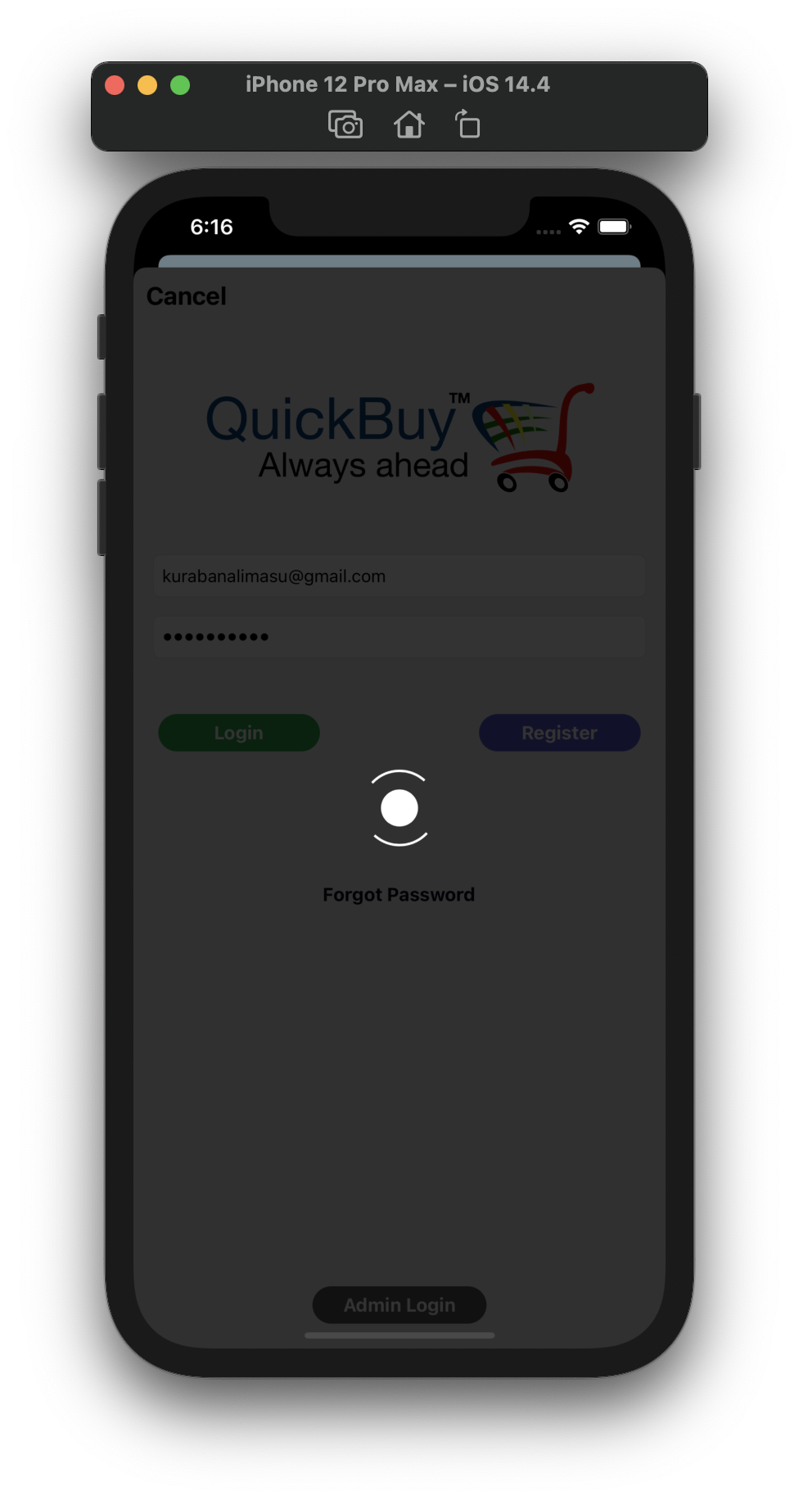

* Category view screen

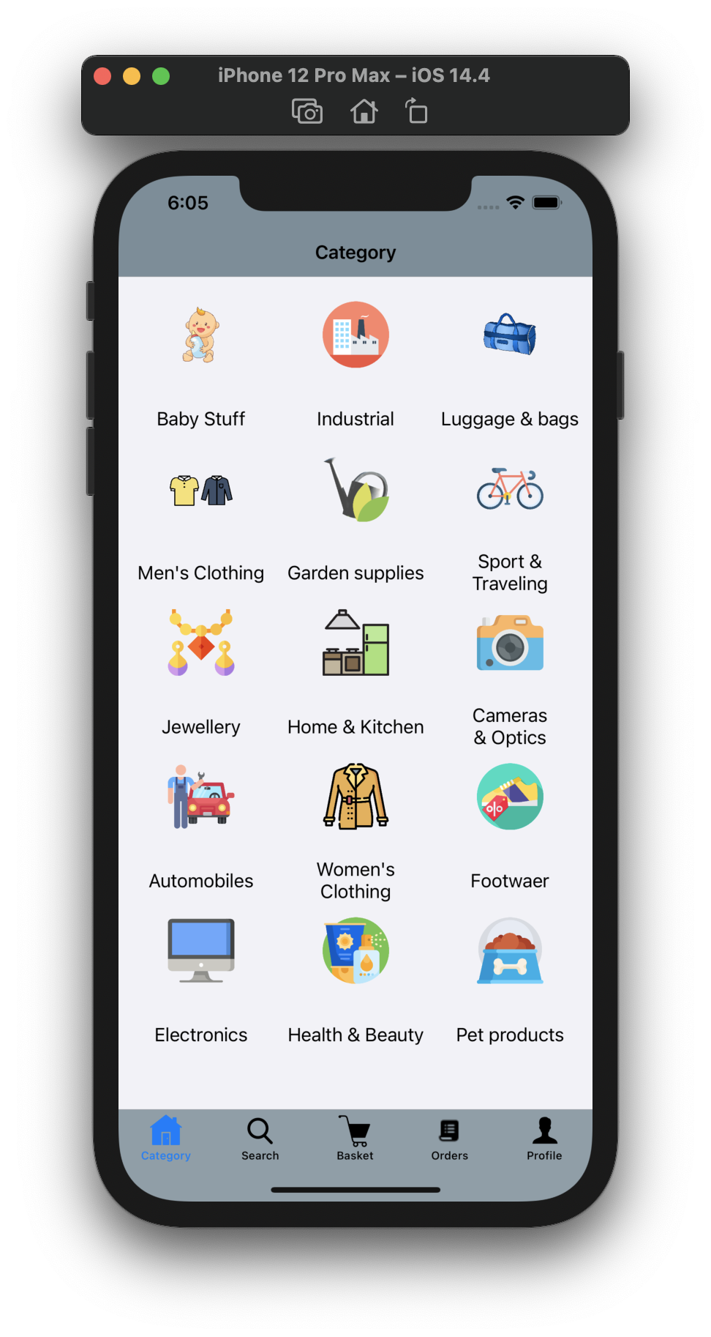

* Items in category

view screen

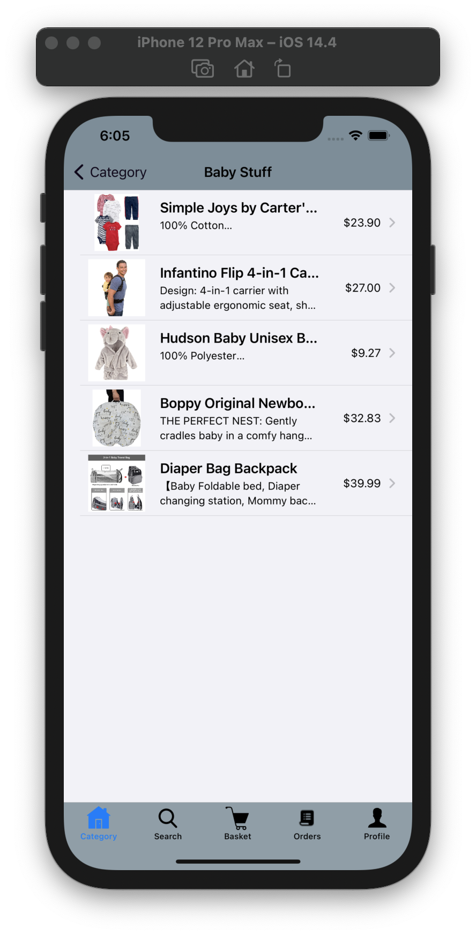

* Items view screen

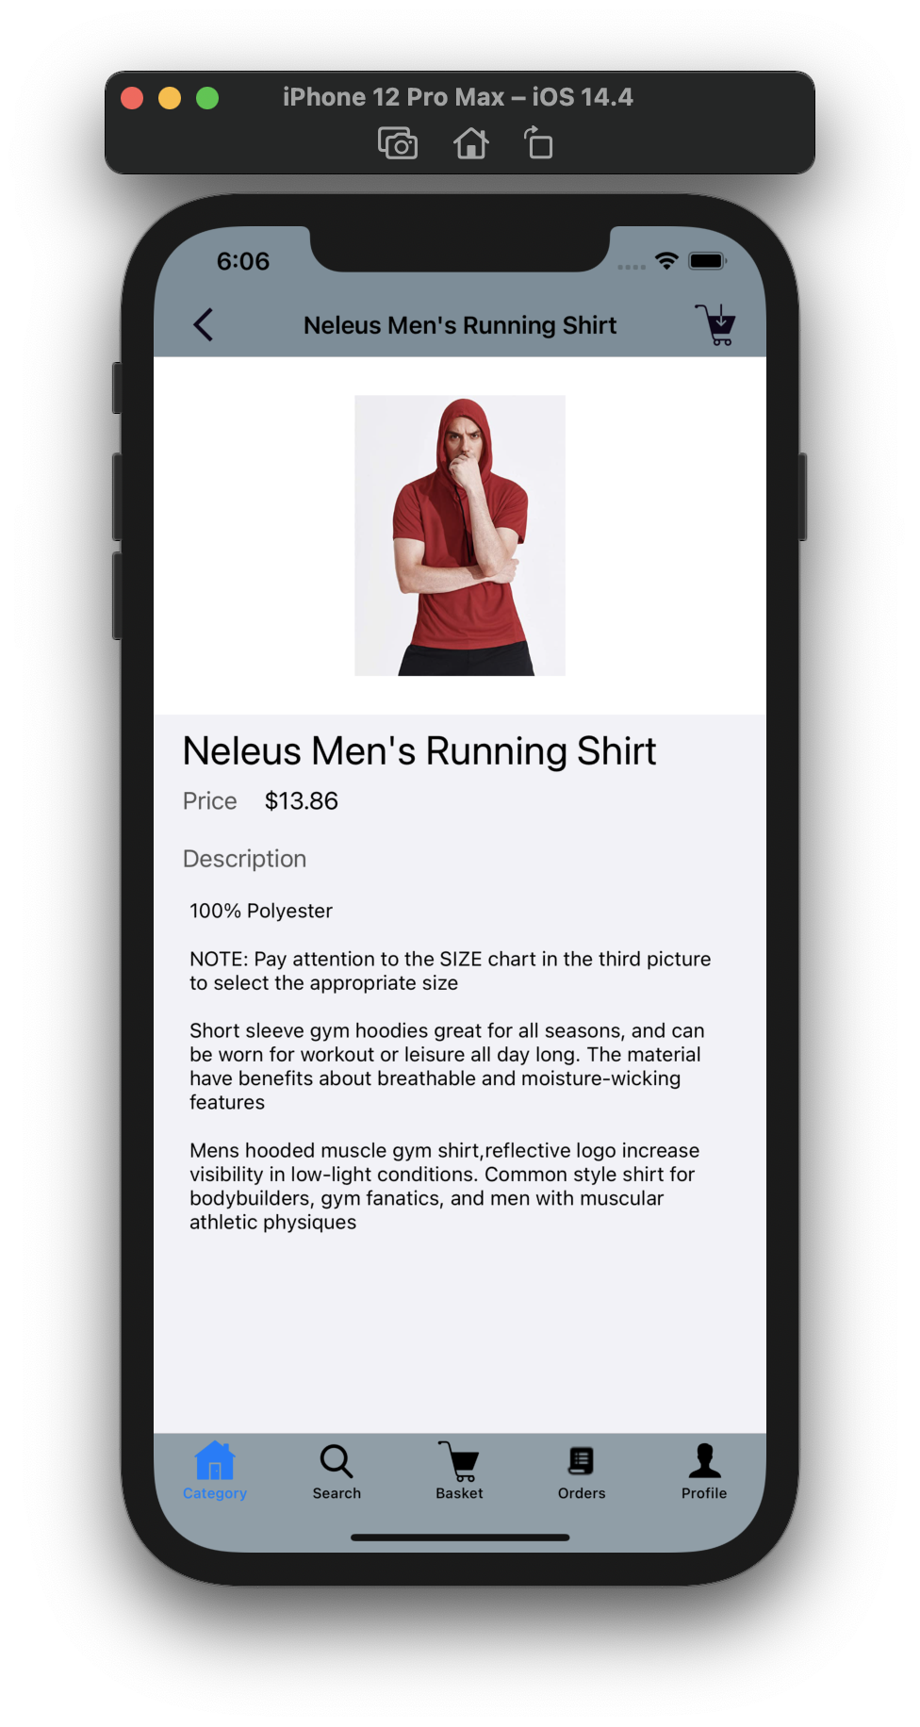

* Search view screen

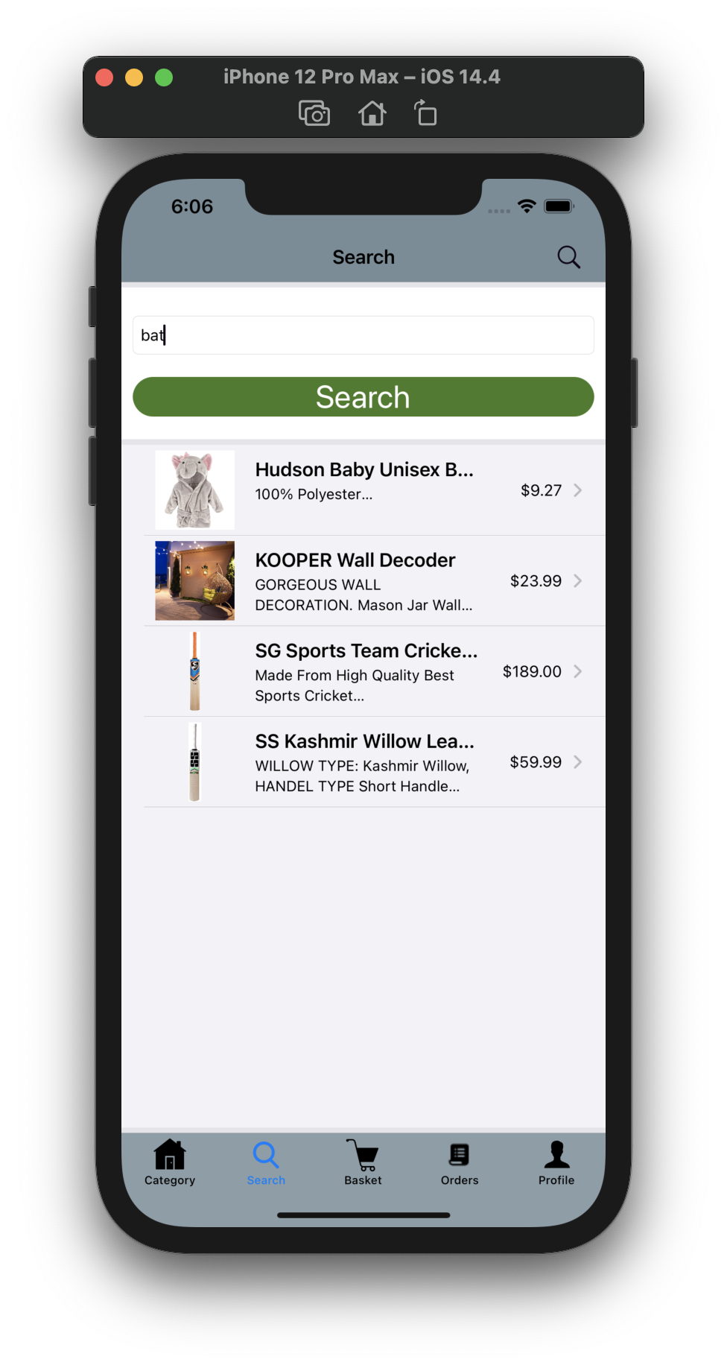

* Cart view screen

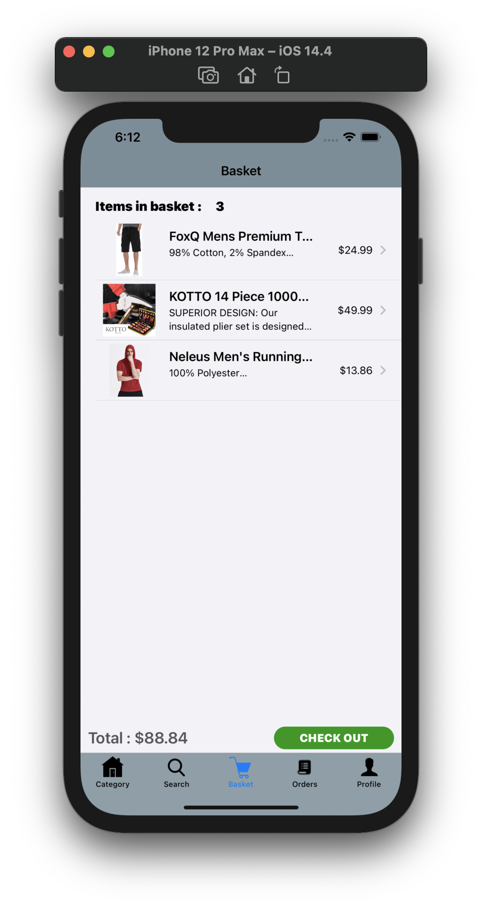

* Confirm order

view screen

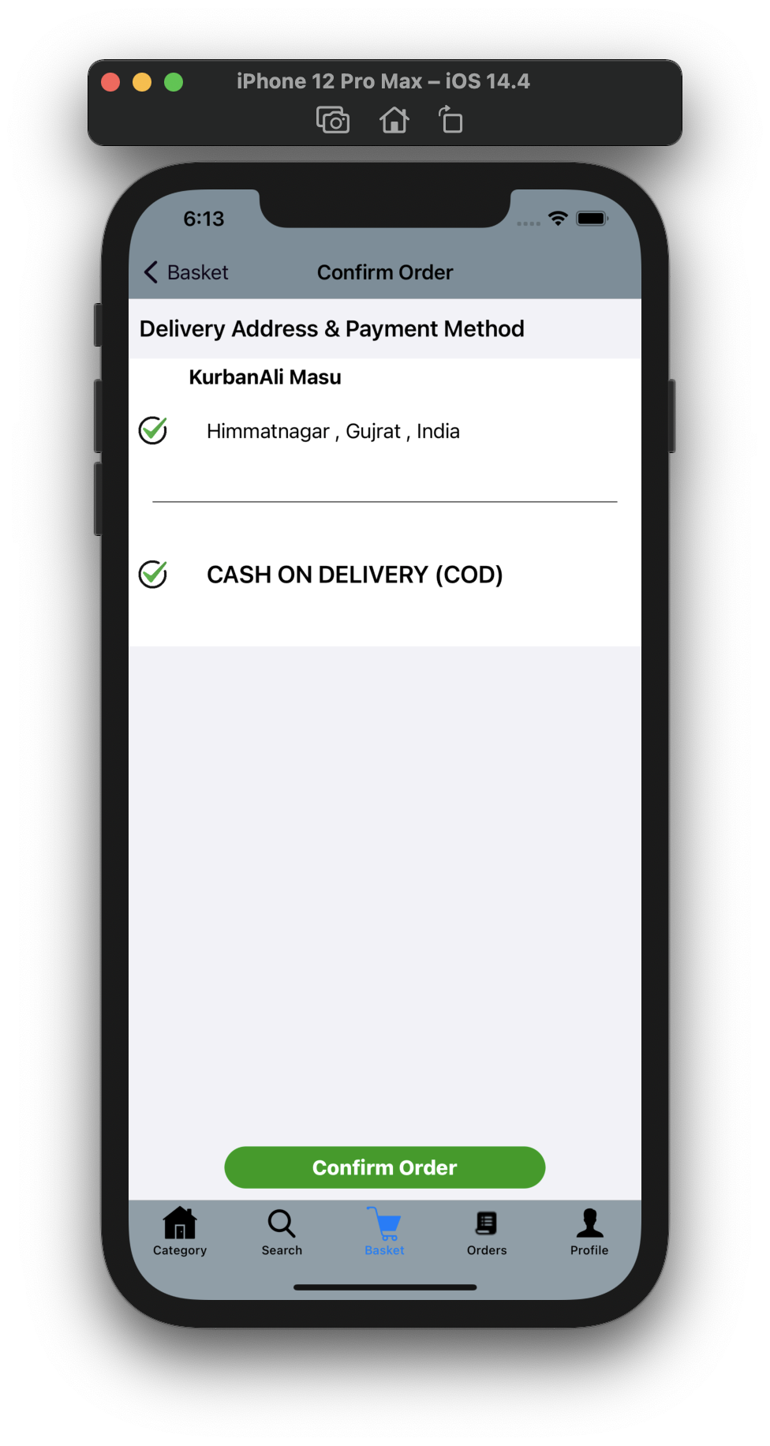

* Orders view screen

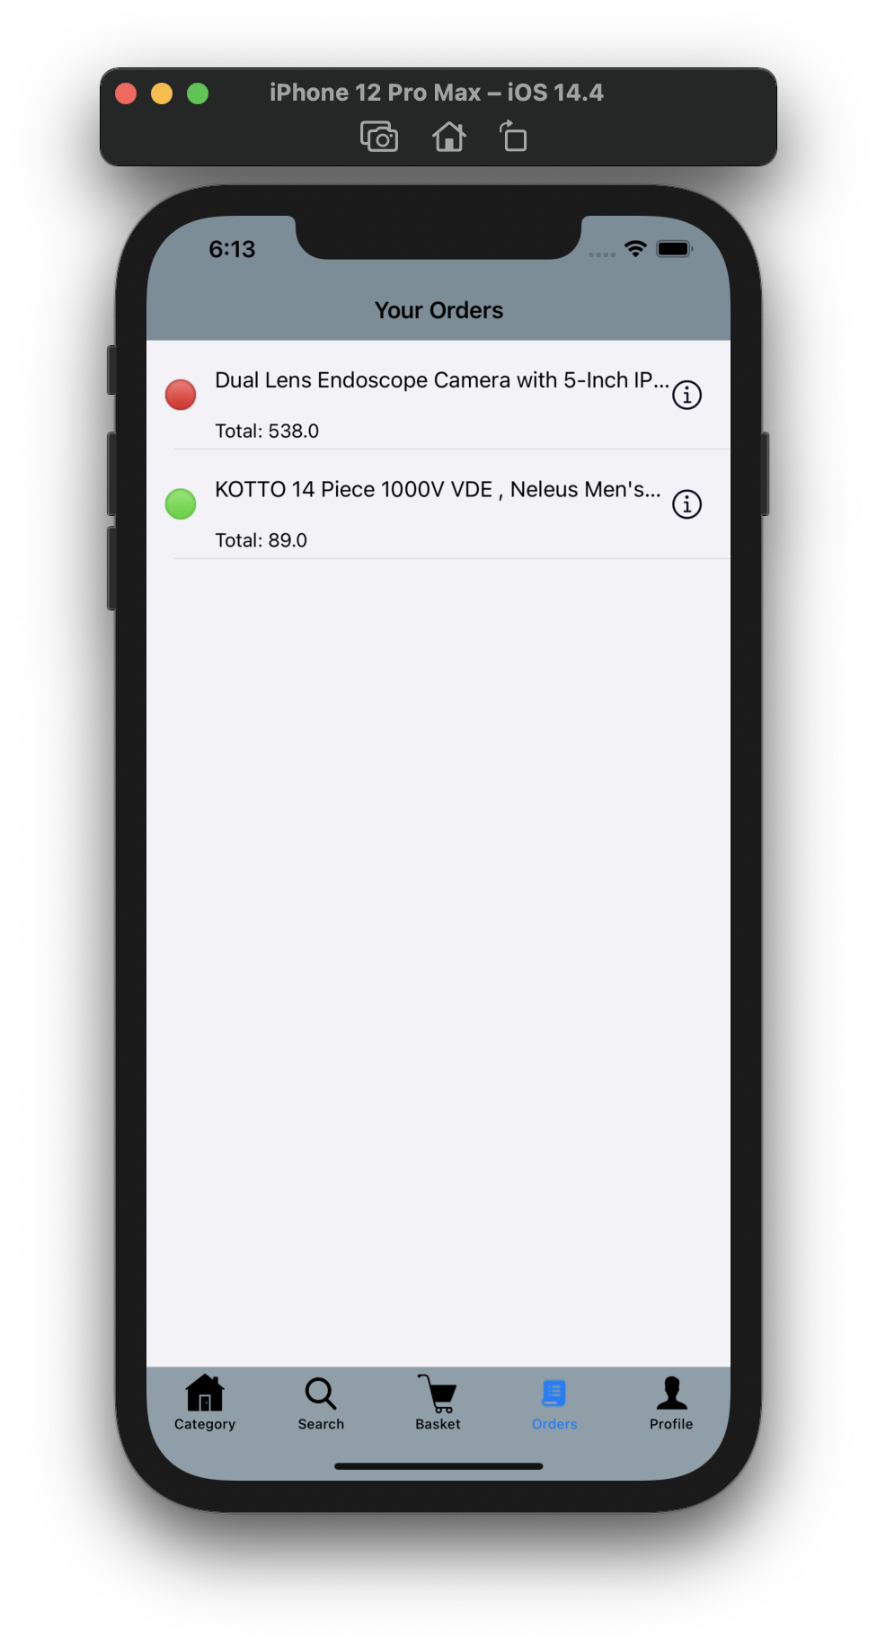

* Order details

view screen

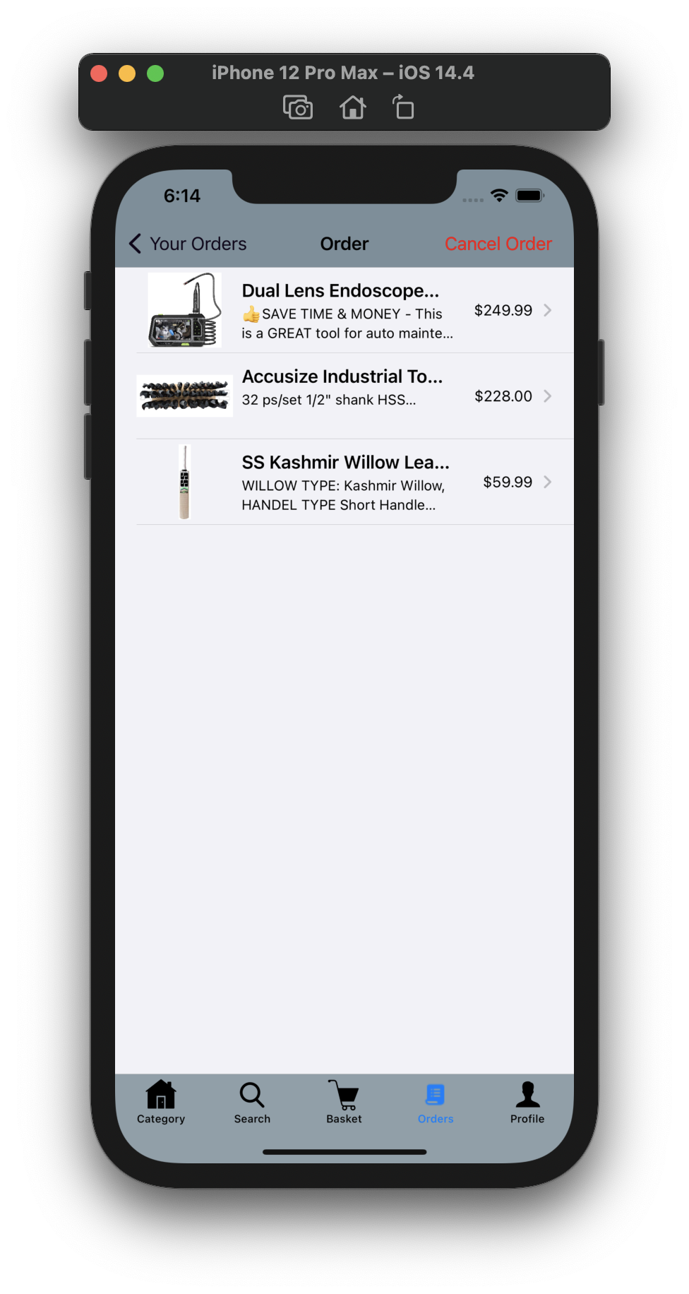

* Profile view screen

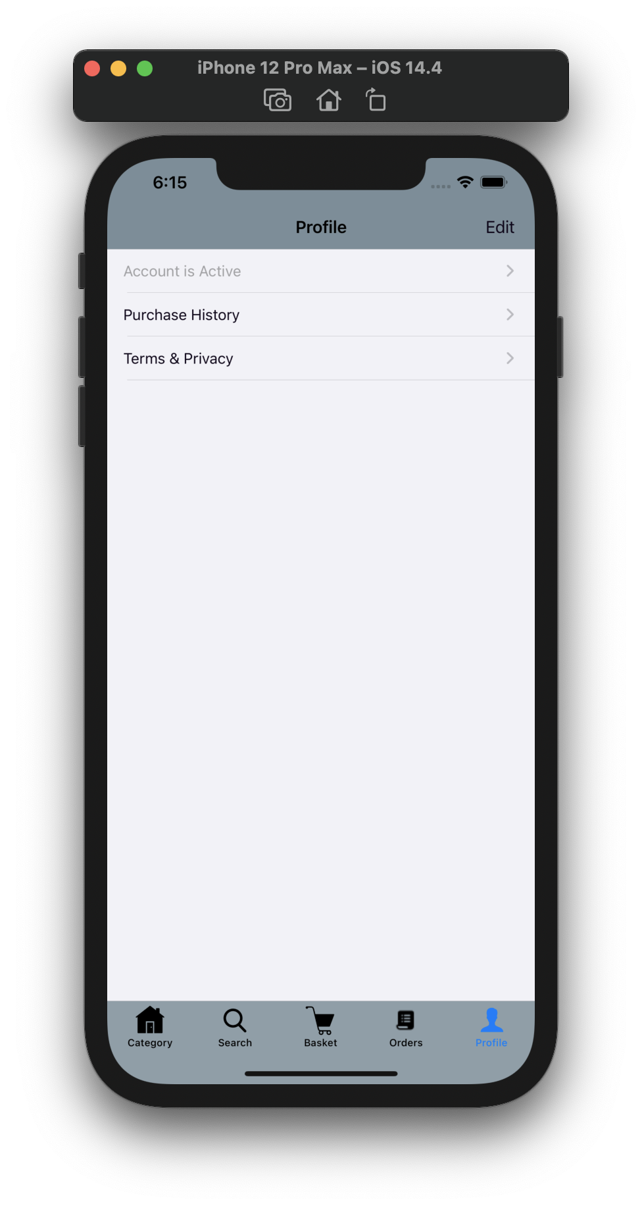

* Edit profile

view screen

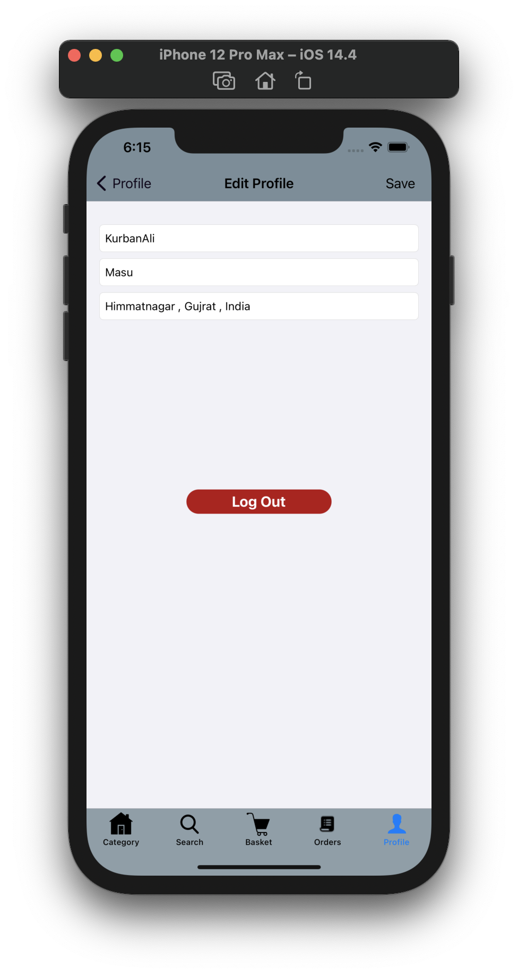

* Purchase history

view screen

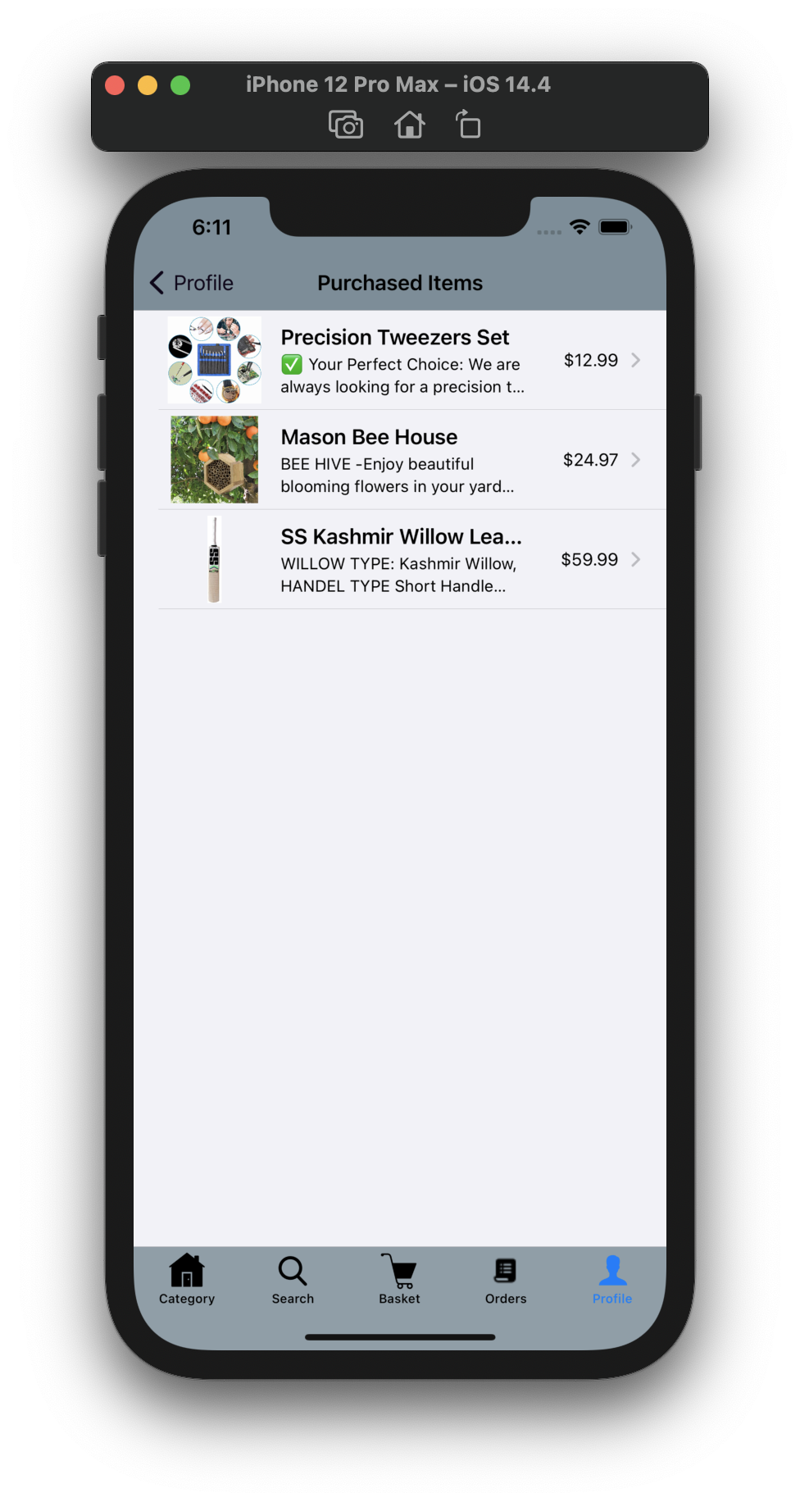

* Terms and privacy

view screen

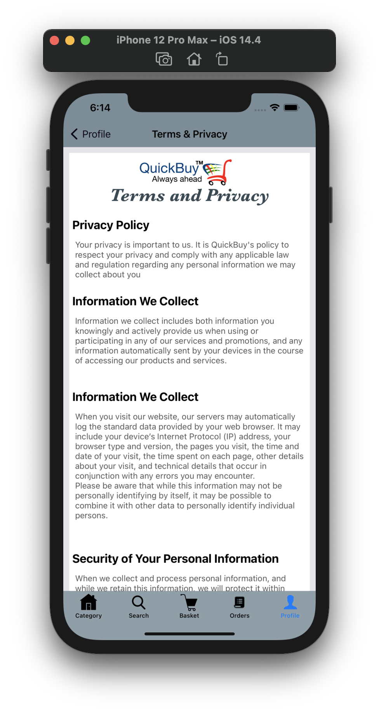

**14. ADMIN SIDE DESIGN**

* Login Screen

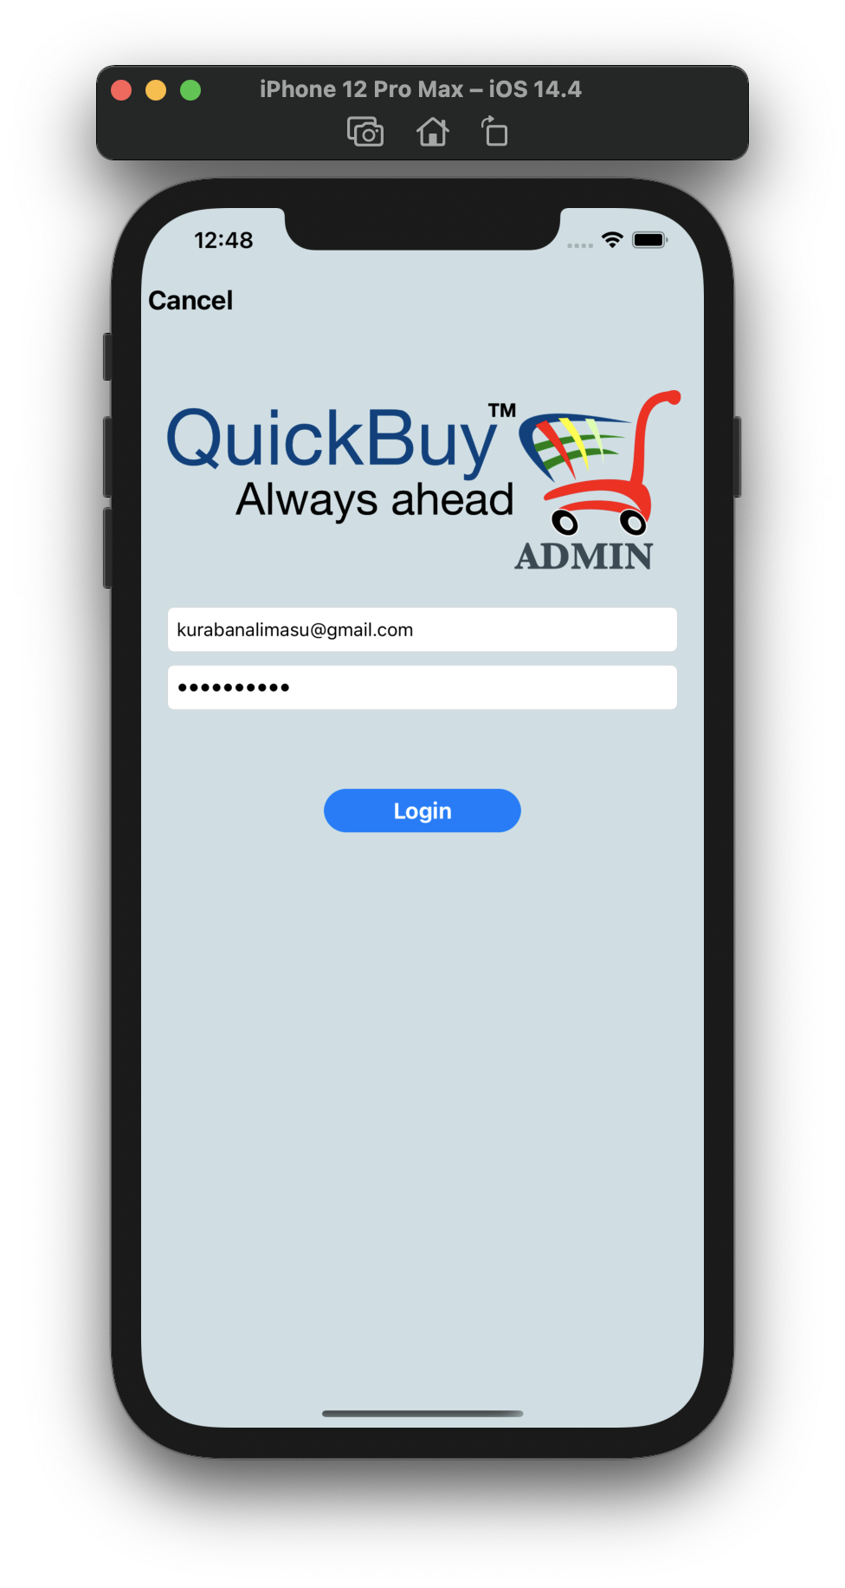

* Login Screen

loading indicator

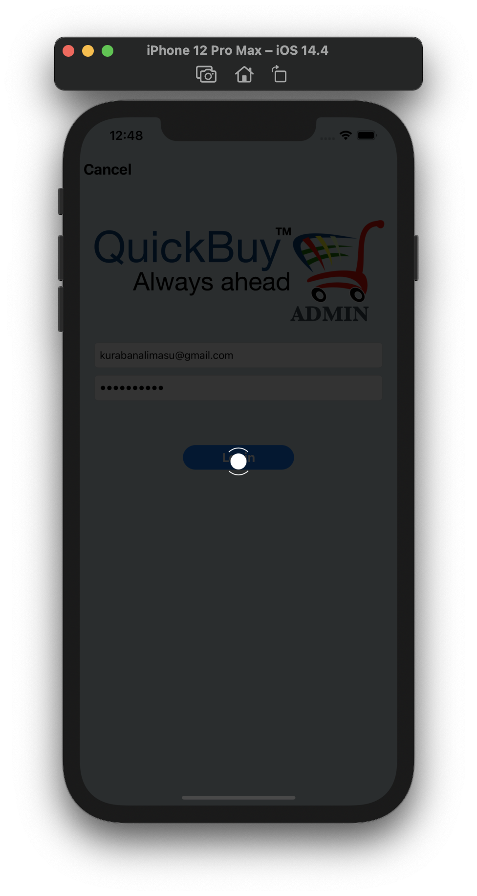

* Category screen

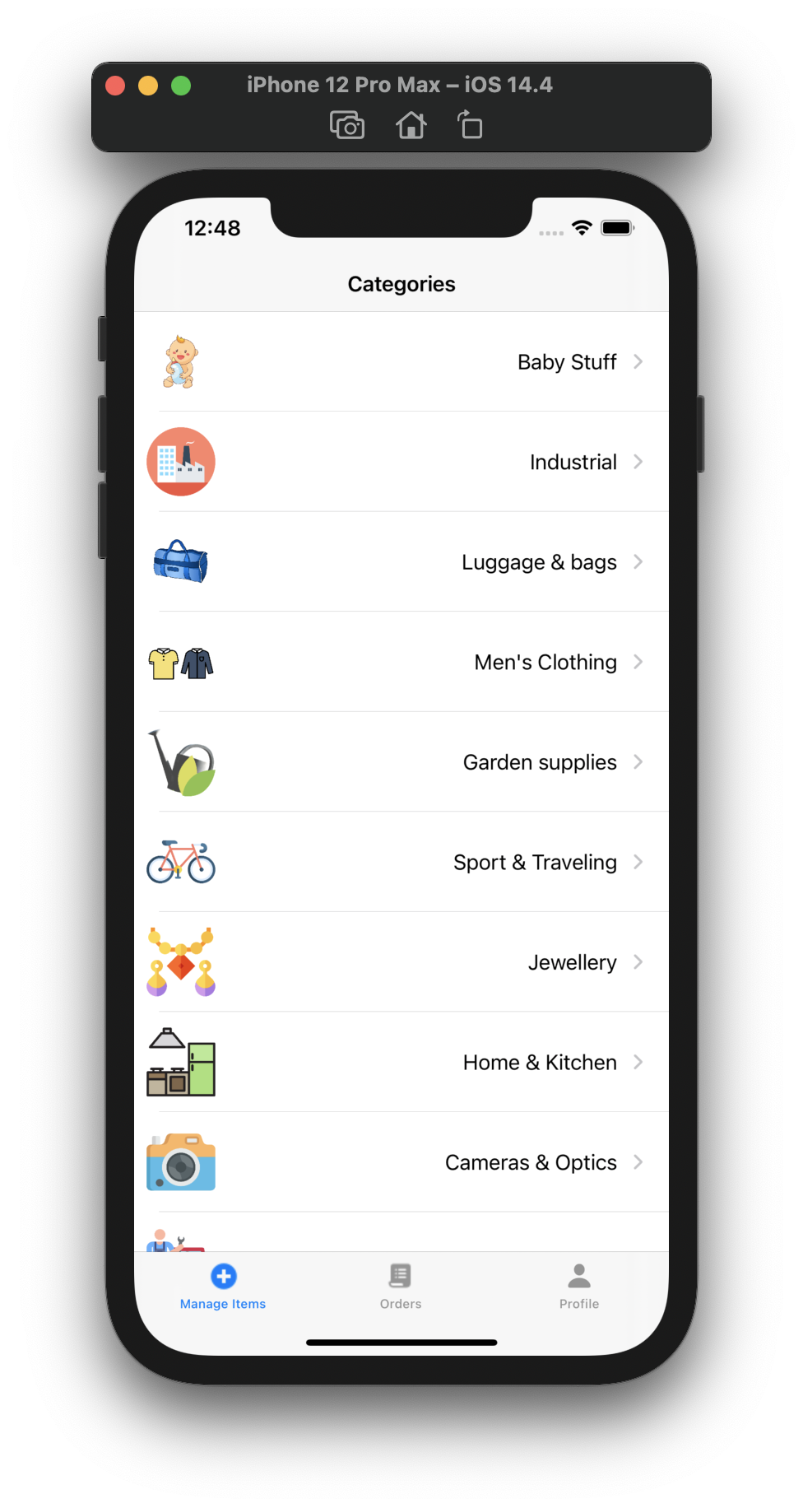

* Items in Category

screen

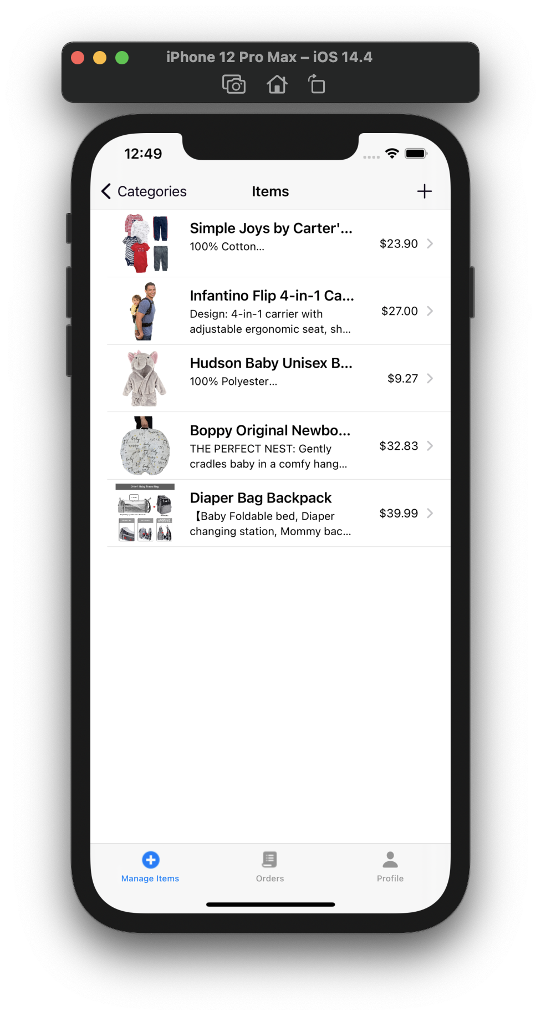

* Add item screen

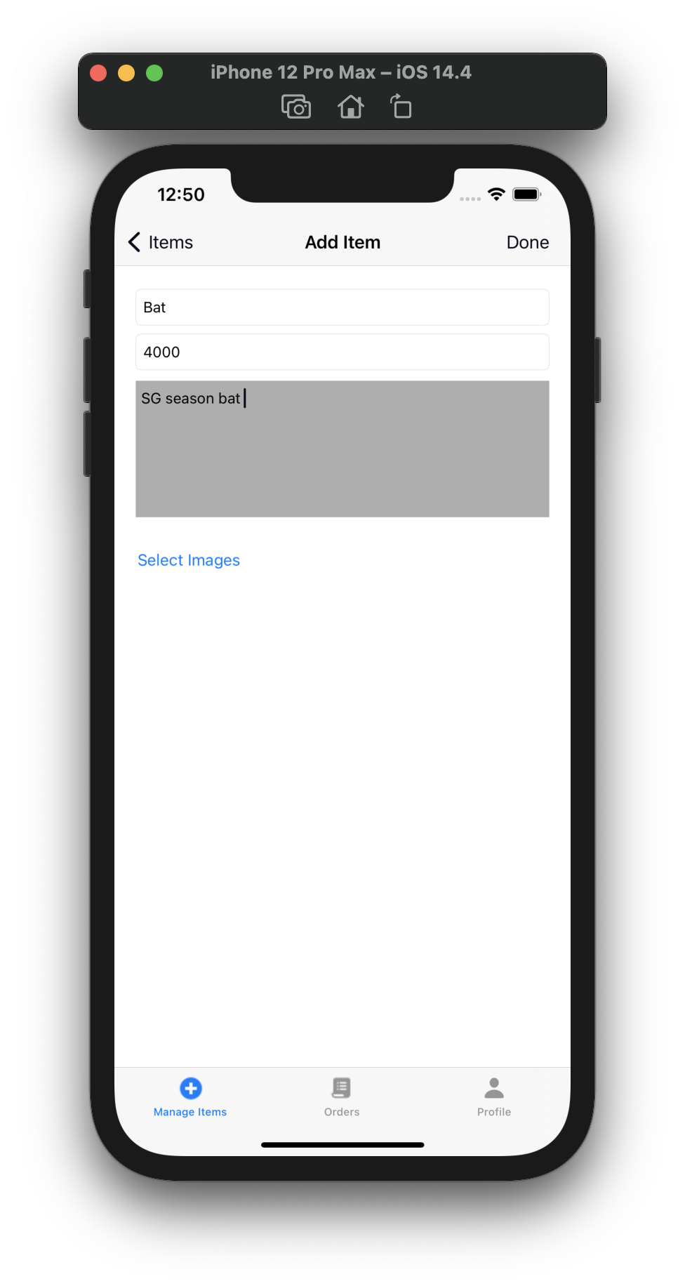

* Image selection

in add item

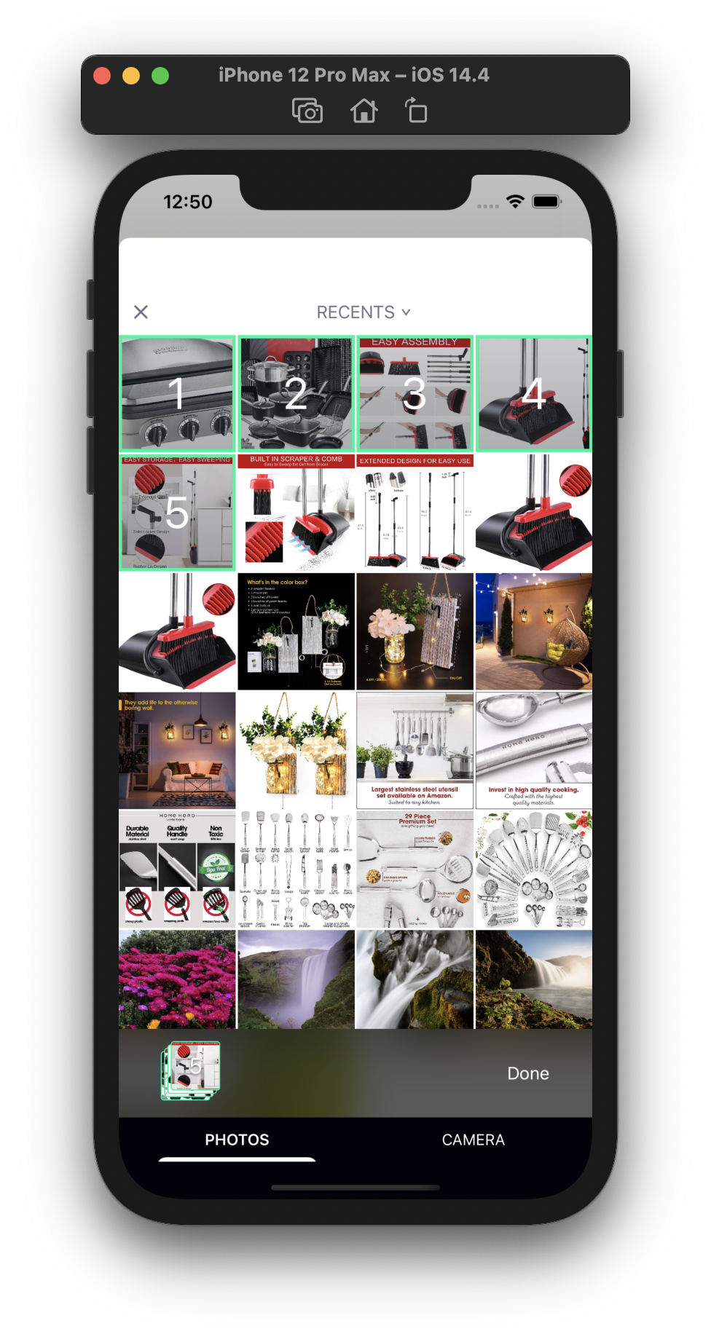

* Update Item

screen

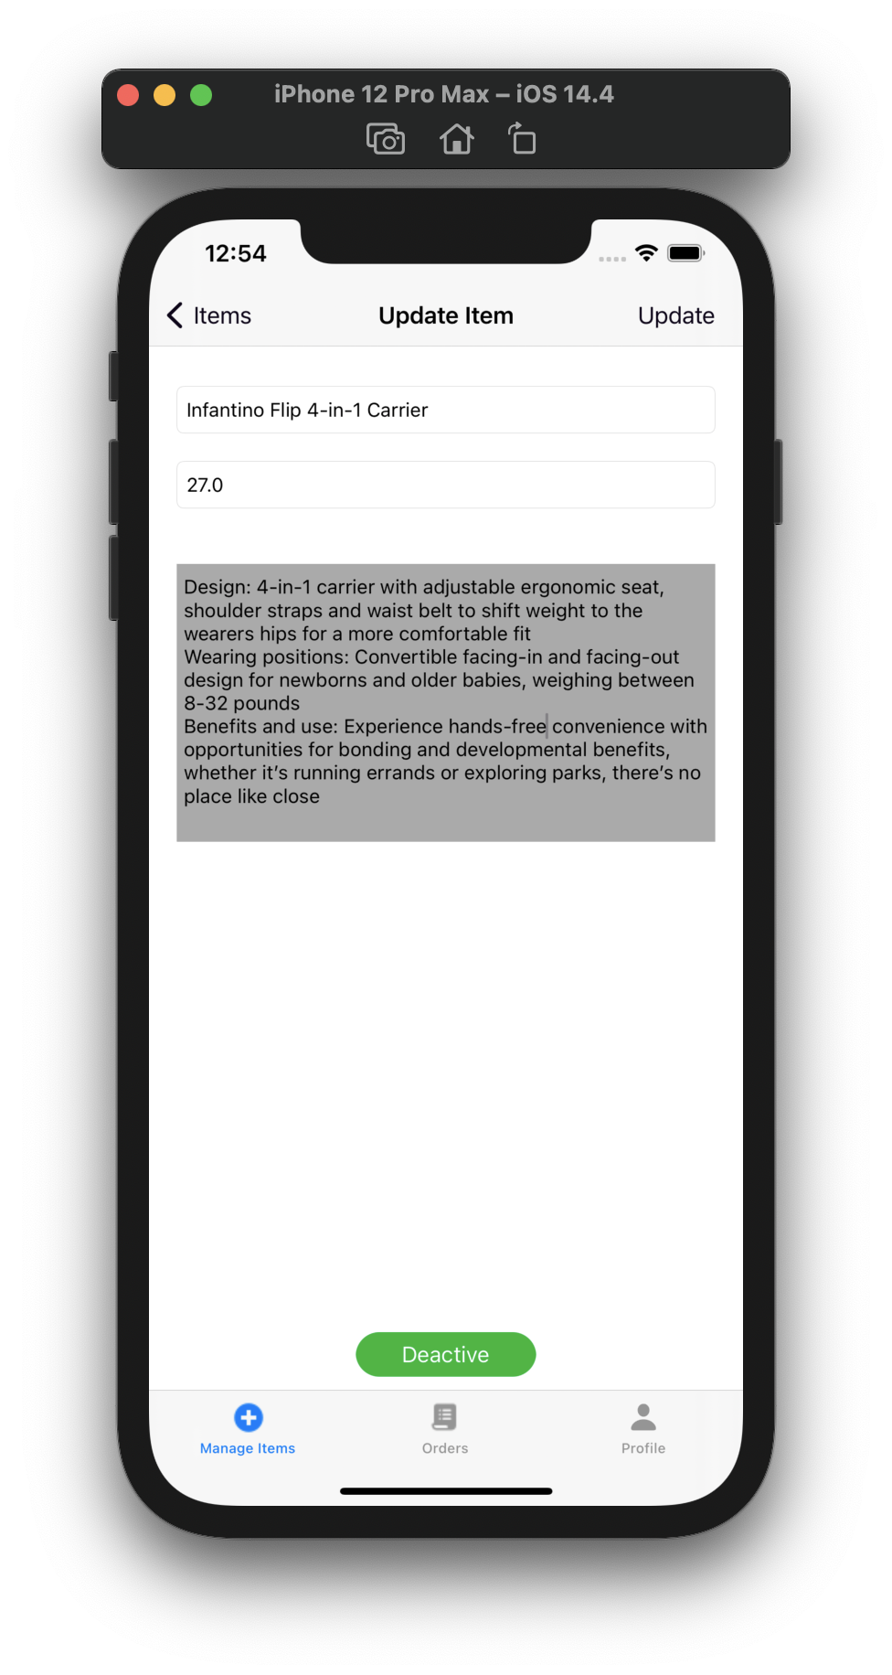

* All orders view

screen

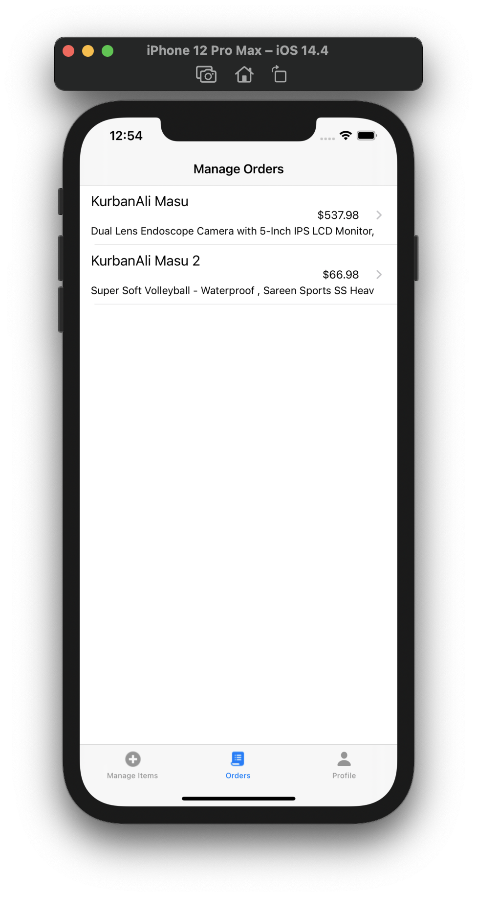

* Order view

screen

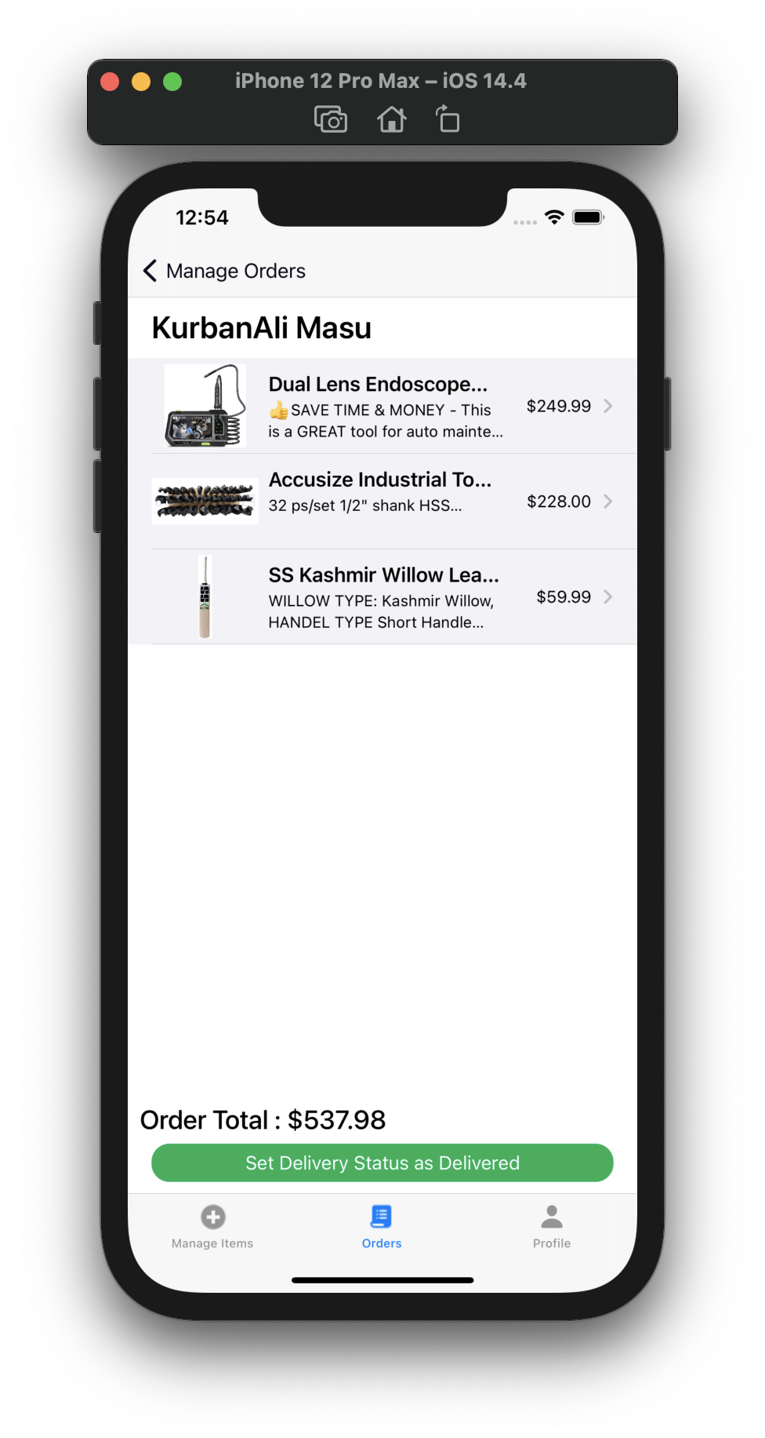

* Logout Screen

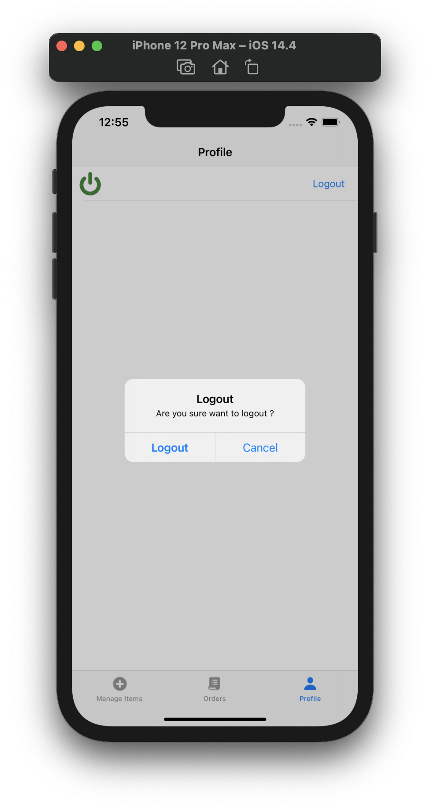

**15. TEST CASES**

|  |  |  |  |  |  |  |  |
| --- | --- | --- | --- | --- | --- | --- | --- |
| **NO** | **Test Cases** | **Test case id** | **Test Case Description** | **Test Data** | **Expected Result** | **Actual Result** | **Pass / Fail** |
| **1** | **LOGIN** | 1.1 | Check response when valid email and password is entered | Email:  [kurabanalimasu@gmail.com](mailto:kurabanalimasu@gmail.com)  Password:  kurban@123 | login should be successful | Login was successful | Pass |
| 1.2 | Check response with non-verified email and password | Email:  kurbanali@gmail.com  Password:  kurban@123 | Show error of email not verified | Showing error email is not verified | Pass |
| 1.3 | Check response when invalid email and password entered | Email:  kurbanali123@gmail.com  Password:  kurban@12345 | Showing error no record corresponding to this identifier | Pass |  |

**TEST CASES : LOGIN**

|  |  |  |  |  |  |  |  |
| --- | --- | --- | --- | --- | --- | --- | --- |
| **NO** | **Test Cases** | **Test case id** | **Test Case Description** | **Test Data** | **Expected Result** | **Actual Result** | **Pass / Fail** |
| **1** | **LOGIN** | 1.4 | Try to login with empty text Field | - | Show error of all fields are required | Showing error of all fields are required | Pass |

**TEST CASES : REGISTRATION**

|  |  |  |  |  |  |  |  |
| --- | --- | --- | --- | --- | --- | --- | --- |
| **NO** | **Test Cases** | **Test case id** | **Test Case Description** | **Test Data** | **Expected Result** | **Actual Result** | **Pass / Fail** |
| **2** | **REGISTRATION** | 2.1 | Check response when register with valid email address and password | Email:  john122@gmail.com  Password:  john@#123 | Send verification mail to email address | Sending email to the mail address | Pass |
| 2.2 | Check response with invalid email and password | Email:  [john24553333@gmail.com](mailto:john24553333@gmail.com/)  Password :  john@@9078567 | Show error of email address badly formatted | Showing error of email address badly formatted | Pass |
| 2.3 | Check response when try to register with already registered email | Email:  kurabanalimasu@gmail.com  Password:  kurban@123 | Show error of this email is used by another user | Showing error of this email is used by another user | Pass |

|  |  |  |  |  |  |  |  |
| --- | --- | --- | --- | --- | --- | --- | --- |
| **NO** | **Test Cases** | **Test case id** | **Test Case Description** | **Test Data** | **Expected Result** | **Actual Result** | **Pass / Fail** |
| **2** | **REGISTRATION** | 2.4 | Try to Register with password length less then 6 characters | Email:  jack221@gmail.com  Password:  jack | Show error of password must have 6 or grater characters | Showing error of password must have 6 or grater characters | Pass |
| 2.5 | Try to register with empty fields | - | Show error of all fields are required | Showing error of all fields are required | Pass |

**TEST CASES : PURCHASE ITEM**

|  |  |  |  |  |  |  |  |
| --- | --- | --- | --- | --- | --- | --- | --- |
| **NO** | **Test Cases** | **Test case id** | **Test Case Description** | **Test Data** | **Expected Result** | **Actual Result** | **Pass / Fail** |
| **3** | **PURCHASE**  **ITEM** | 3.1 | Add active item to cart | - | Item will add to cart | Item added to cart | Pass |
| 3.2 | Add inactive item to cart | - | It will show error of item in not available currently | showing error of item in not available currently | Pass |
| 3.3 | Add item to cart without login | - | It will redirect on login screen | Redirecting on login screen | Pass |

**TEST CASES : SEARCH ITEM**

|  |  |  |  |  |  |  |  |
| --- | --- | --- | --- | --- | --- | --- | --- |
| **NO** | **Test Cases** | **Test case id** | **Test Case Description** | **Test Data** | **Expected Result** | **Actual Result** | **Pass / Fail** |
| **4** | **SEARCH ITEM** | 4.1 | Search the item with valid item name | Item Name : Bag | It will show all bags | showing all bags | Pass |
| 4.2 | Search item with empty field | - | It will show the error of all fields are required | showing the error of all fields are required | Pass |

**TEST CASES : ORDER**

|  |  |  |  |  |  |  |  |
| --- | --- | --- | --- | --- | --- | --- | --- |
| **NO** | **Test Cases** | **Test case id** | **Test Case Description** | **Test Data** | **Expected Result** | **Actual Result** | **Pass / Fail** |
| **5** | **ORDER** | 5.1 | Check out all the cart items and order | - | It will confirm order then place order | Confirm order then placed order | Pass |
| 5.2 | Cancel the order from orders | - | It will cancel the order | Cancelled order | Pass |

**16. LIMITATIONS OF SYSTEM**

* In this system we can’t manage the stock of the items.
* In this system we can’t see the order delivery status.
* In this system there is not online payment method.
* In this system user can’t add multiple address.

**17. FUTURE ENHANCEMANT**

* We will provide web application.
* We will provide Separate app for user and admin.
* We will provide order delivery status with the notification.
* We will provide online payment method.
* We will provide return and refund system

**18. BIBLIOGRAPHY**

[https://swift.org](https://swift.org/)

[https://cocoapods.org](https://cocoapods.org/)

[https://stackoverflow.com](https://stackoverflow.com/)

<https://firebase.google.com/docs>

[https://github.com](https://github.com/)

[https://www.ioscreator.com](https://www.ioscreator.com/)

**THANK YOU**